**Lesson 5 Demo 4**

**Understanding Security Context**

**Objective:**  To set the security context for a container

**Tools required:** kubeadm, kubectl, kubelet, and etcd

**Prerequisites:** kubeadm, kubectl, kubelet, and etcd should be installed

Steps to be followed:

1. Creating the security context
2. Verifying the security context
3. Getting a shell into the running container

**Step 1: Creating the security context**

* 1. Open **security.yaml** using the below command:

**vi security-context.yaml**

1.2 Copy and paste the below code to **security.yaml**:

**apiVersion: v1**

**kind: Pod**

**metadata:**

**name: security-context-1**

**spec:**

**securityContext:**

**runAsUser: 1000**

**runAsGroup: 3000**

**fsGroup: 2000**

**volumes:**

**- name: sec-ctx-vol**

**emptyDir: {}**

**containers:**

**- name: sec-ctx-demo**

**image: busybox:1.28**

**command: [ "sh", "-c", "sleep 1h" ]**

**volumeMounts:**

**- name: sec-ctx-vol**

**mountPath: /data/demo**

**securityContext:**

**allowPrivilegeEscalation: false**

* 1. Create the security context using the following command:

**kubectl apply -f security-context.yaml**

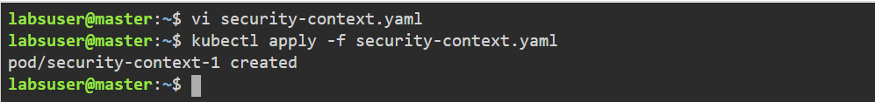

**Step 2: Verifying the security context**

2.1 Verify **security-context** using the following command:

**kubectl get pod security-context-1**

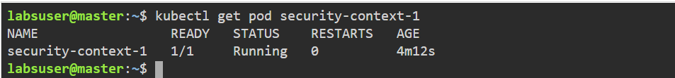

**Step 3: Getting a shell into the running container**

3.1 Get a shell into the running container:

**kubectl exec --stdin --tty security-context-1 – sh**

3.2 In the shell, list the running processes with the below command:

**ps**

3.3 In the shell, navigate to **/data**, and list the **one** directory:

**cd /data**

**ls**

**ls -l**

The output shows that the **/data/demo** directory has group ID 2000, which is the value of **fsGroup**. This is shown in the screenshot below:

3.4 In the shell, navigate to **/data/demo**, and create a file using the following commands:

**cd demo**

**echo hello > testfile**

3.5 List the file in the **/data/demo** directory:

**ls -l**

3.6 Run the following command to get the respective user ID and group ID:

**id**

3.7 Exit the shell using the below command:

**Exit**

